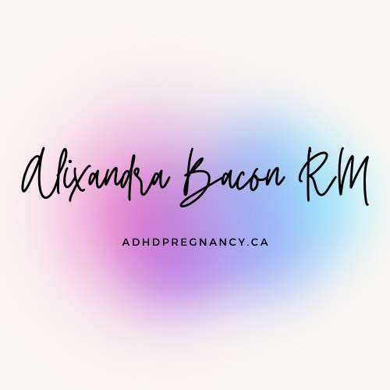ADHDPregnancy.ca Alixandra Bacon, RM MA Registered Midwife

Tel 604-786-1192

Fax NEW TOLL FREE! 1-833-333-1464

[alixandra@adhdpregnancy.ca](mailto:alixandra@adhdpregnancy.ca) MSP #89277 BCCNM #1278

**Referring Care Provider** (Midwife, Physician, Nurse Practitioner, Nurse or Social Worker)

Date of Referral

Name of Referrer MSP billing #

(Use '99987' for NR, NP and RSW)

Office Fax

Office Phone

**Client** (pregnant/birthing person) Pronouns:

Name on Carecard

Date of Birth CareCard PHN Phone

Address

Email

EDD/Date of Birth

Formal Diagnosis?

Medications?

Please email completed form to [alixandra@adhdpregnancy.ca](mailto:alixandra@adhdpregnancy.ca) or Fax to 1  833  333  1464

Thank you for your referral. Clients will be contacted directly to make an appointment.

*Please note MSP covers up to 4 sessions total and only until 6 weeks

postpartum